**Experiment 1.**

* **Aim:** Design an LED flasher
* **Circuit Diagram:**



$Theory:$

**LEDs are all around us:** In our phones, our cars and even our homes. Any time something electronic lights up, there’s a good chance that an LED is behind it. They come in a huge variety of sizes, shapes, and colors.

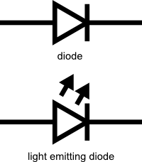LEDs are like tiny lightbulbs. However, LEDs require a lot less power to light up by comparison. They’re also more energy efficient, so they don’t tend to get hot like conventional lightbulbs do (unless you’re really pumping power into them). This makes them ideal for mobile devices and other low-power applications. Don’t count them out of the high-power game, though. High-intensity LEDs have found their way into accent lighting, spotlights and even automotive headlights!

# Polarity Matters

In electronics, polarity indicates whether a circuit component is symmetric or not. LEDs, being diodes, will only allow current to flow in one direction. And when there’s no current-flow, there’s no light. Luckily, this also means that you can’t break an LED by plugging it in backwards. Rather, it just won’t work.

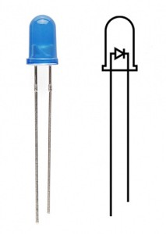

The positive side of the LED is called the **“anode”** and is marked by having a longer “lead,” or leg. The other, negative side of the LED is called the **“cathode.”** Current flows from the anode to the cathode and never the opposite direction. A reversed LED can keep an entire circuit from operating properly by blocking current flow. So don’t freak out if adding an LED breaks your circuit. Try flipping it around.

# More Current Equals More Light

The brightness of an LED is directly dependent on how much current it draws. That means two things. The first being that super bright LEDs drain batteries more quickly, because the extra brightness comes from the extra power being used. The second is that you can control the brightness of an LED by controlling the amount of current through it. But, setting the mood isn’t the only reason to cut back your current.

# There is Such a Thing as Too Much Power

If you connect an LED directly to a current source it will try to dissipate as much power as it’s allowed to draw. That’s why it’s important to limit the amount of current flowing across the LED.

For this, we employ resistors. Resistors limit the flow of electrons in the circuit and protect the LED from trying to draw too much current.

* **Problems & Troubleshooting:**

*Problems:*

1. The LED was not Glowing Brightly at first.
2. Arduino had some issue whilst uploading the code.

*Troubleshooting*

1. Replacing the LED with another one
2. The port selection on the computer was done again, it resolved it.

* **Precautions:**

1. When dealing with extremely small components such as LED, Resistors or switches one must take care that they are not broken or lost while connecting on the breadboard.
2. The LED should not be connected in a reverse manner or else it won’t work.
3. The connections should be tight and proper.
4. The code must be prepared in a way so that it solves the purpose.

* **Learning Outcomes:**

From this Experiment of LED Flasher, I have learnt:

1. Working of multi-meter.
2. The connections on a breadboard.
3. The working of an Arduino.
4. The coding and error resolving for Arduino.
5. The fundamentals of electricity.
6. The use of resistor.